 | MONDIAL JEUNES  Under 18 / Under 23  CHIERI (Italie) | 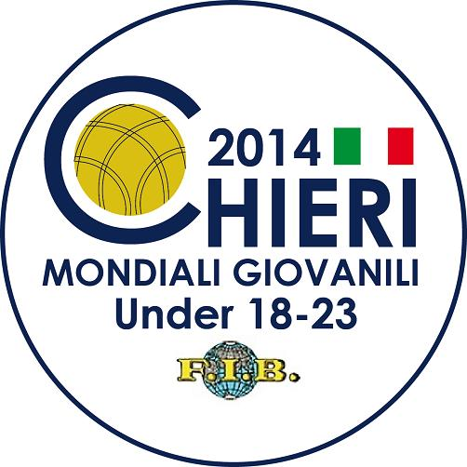

 | TIR PROGRESSIF - TIRO PROGRESSIVO

QUALIFICATIONS
1. | MON | TRICHARD Alexandre | 29/47 | Q | 11. | SRB | BUTORAC Srdjan | 29/41 | Q
2. | CIV | LOGBO Djedjé Hugues | Abs |  | 12. | CHI | BARBANO Franco | 31/45 | Q
3. | PAR | CACERES Dilsou | 17/46 | Q | 13. | ARG | PRETTO Nicolas | 35/41 | Q
4. | FRA | LEIVA MARCON Sébastien | 42/48 | Q | 14. | AUS | SAMSA Daniel | 18/43 | Q
5. | CRO | BRNIC Leo | 47/49 | Q | 15. | SUD | OBAI Salah | 5/36
6. | DJI | HAMZA Mohamed Ali | 4/39 |  | 16. | ITA | MANA Simone | 43/47 | Q
7. | MNE | DUROVIC Mihajlo | 31/45 | Q | 17. | SVK | PAVCO Patrik | 15/43
8. | BUL | RADEV Filip | 17/46 | Q | 18. | ALG | BOUFATEH Sid Ahmed | 22/43 | Q
9. | BIH | CORLUKA Andrija | 35/46 | Q | 19. | SLO | KAVCIC Matej | 40/48 | Q
10. | TUN | KHMIRI Wassim | 30/45 | Q | 20. | TUR | HAMDI Rusten | 28/45 | Q

1/8ème DE FINALE
1. | PAR | CACERES Dilsou | 21/45 |  | 9. | MNE | DUROVIC Mihajlo | 27/44
2. | BUL | RADEV Filip | 16/45 |  | 10. | CHI | BARBANO Franco | 33/47 | Q
3. | AUS | SAMSA Daniel | 29/46 |  | 11. | BIH | CORLUKA Andrija | 34/46 | Q
4. | ALG | BOUFATEH Sid Ahmed | 24/44 |  | 12. | ARG | PRETTO Nicolas | 37/43 | Q
5. | TUR | HAMDI Rusten | 37/46 | Q | 13. | SLO | KAVCIC Matej | 40/49 | Q
6. | MON | TRICHARD Alexandre | 28/46 |  | 14. | FRA | LEIVA MARCON Sébastien | 36/49 | Q
7. | SRB | BUTORAC Srdjan | 31/43 |  | 15. | ITA | MANA Simone | 41/48 | Q
8. | TUN | KHMIRI Wassim | 32/46 |  | 16. | CRO | BRNIC Leo | 46/48 | Q

1/4 DE FINALE
1. | CHI | BARBANO Franco | 36/47 |  |  | 5. | ARG | PRETTO Nicolas | 35/43
2. | BIH | CORLUKA Andrija | 37/46 | 17/24 |  | 6. | SLO | KAVCIC Matej | 43/48 | Q
3. | FRA | LEIVA MARCON Sébastien | 37/50 | 25/26 | Q | 7. | ITA | MANA Simone | 41/46 | Q
4. | TUR | HAMDI Rusten | 31/46 |  |  | 8. | CRO | BRNIC Leo | 42/48 | Q

1/2 FINALE
1. | FRA | LEIVA MARCON Sébastien | 44/51 | Q | 3. | CRO | BRNIC Leo | 44/48 | Q
2. | ITA | MANA Simone | 41/49 |  | 4. | SLO | KAVCIC Matej | 30/45

FINALE
1. | FRA | LEIVA MARCON Sébastien |  |  | 2. | CRO | BRNIC Leo

PODIUM
 | ITA | MANA Simone | SLO | KAVCIC Matej

